**CS 487 DATA SECURITY**

**HOP02 – Deploy Virtual Network(s)**

12/14/2020 Developed by Mary Oh

Center for Information Assurance (CIAE) @City University of Seattle (CityU)

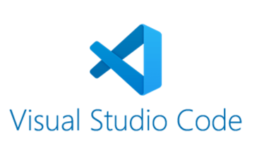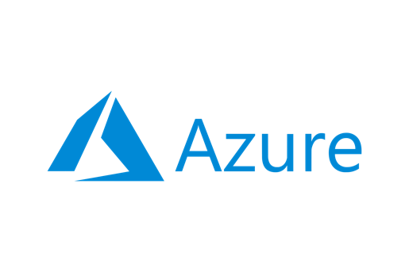

**Before You Start**

* Version numbers may not match with the most current version at the time of writing. If given the option to choose between stable release (long-term support) or most recent, please choose the stable release rather than beta-testing version.
* This tutorial targets Windows users and MacOS users.
* There might be subtle discrepancies along the steps. Please use your best judgement while going through this cookbook style tutorial to complete each step.
* For your working directory, use your course number. This tutorial may use a different course number as an example.
* The directory path shown in screenshots may be different from yours.
* If you are not sure what to do or confused with any steps:
  + Consult the resources listed below.
  + If you cannot solve the problem after a few tries, ask a TA for help.

**Learning Outcomes**

* Learn how to use Visual Studio Code for Mac to Deploy a Virtual Network

**Resources**

* Microsoft Azure - [https://azure.microsoft.com/](https://azure.microsoft.com/en-us/overview/what-is-azure/?&ef_id=Cj0KCQiAlsv_BRDtARIsAHMGVSac9cd8I7htfl0EVYTYDUBxYJ7mEqQ6dB5bRem2ziaBp-j1Di4wui8aAivlEALw_wcB:G:s&OCID=AID2100131_SEM_Cj0KCQiAlsv_BRDtARIsAHMGVSac9cd8I7htfl0EVYTYDUBxYJ7mEqQ6dB5bRem2ziaBp-j1Di4wui8aAivlEALw_wcB:G:s&gclid=Cj0KCQiAlsv_BRDtARIsAHMGVSac9cd8I7htfl0EVYTYDUBxYJ7mEqQ6dB5bRem2ziaBp-j1Di4wui8aAivlEALw_wcB)

**What is Azure?**

Azure cloud platform is cloud services designed to help bring new solutions to life. You can build, run, and manage application across multiple clouds, on-premises, and at the edge, with the tools and frameworks of your choice.

**What is Virtual Network?**

Azure Virtual Network (VNet) is the fundamental building block for private network in Azure. It enables many types of Azure resources such as Azure Virtual Machine (VM) that allows secure communication with each other, internet, and on-premises networks.

**ARM Template**

1. Download the attached json files.
2. Open the json files with Visual Studio Code.
3. Install Azure Resource Manager (ARM) Tools extension.

1. On the virtualnetwork.parameters.json update the “virtualNetworkName” to your name.

1. On the left-hand side, select the extensions icon. Install the Azure CLI Tools extension.

**Deploying ARM template to Azure**

1. Open the integrated Visual Studio Code terminal using ctrl + ` key.
2. Sign in using your Azure account information. This will open up a new window to sign in.



1. Create the resource group. Enter the following command.

1. Deploy the virtual network template and parameters file.

1. Verify that your deployment was successful. Open your browser and head to your Azure portal. Select Resource Groups.

1. Locate and open the resource group arm-vscode. Verify that the virtual network is successfully deployed.

1. To avoid incurring any unnecessary fees, clean up resources. Type the following command in your terminal and enter y.



1. Verify if successful. Head to your Azure in your web browser and refresh. The arm-vscode resource group should not be showing.

**Push your work to GitHub**

1. Open the integrated Visual Studio Code terminal using ctrl + ` key. Make sure you are in the right path.
2. Type the following command:

git add . (to copy all changes you have made)

git commit -m “Submission for Module 2 - YourGitHubUsername” (To add a message to your submission)

git push origin master (to upload your work to Github)